Physics Summary:

# Describing Motion

Coordinate systems:

Cartesian coordinates (X, Y, Z)

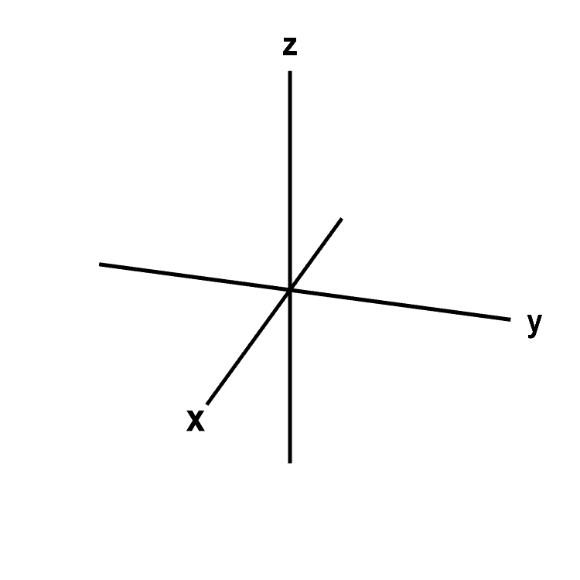

Spherical coordinates (radius, angle, angle)

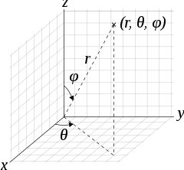

Polar coordinates (radius, angle)

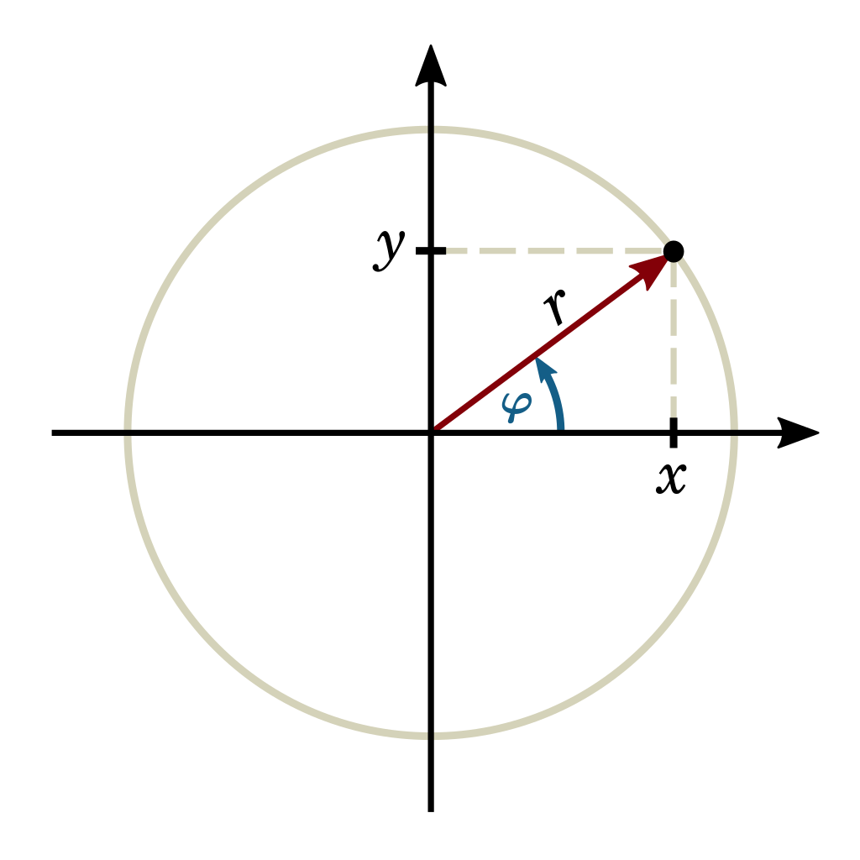

Displacement-Time graph:

Plots the displacement over time.

# Velocity and Speed:



Avg. speed = distance / time

Avg. velocity = displacement / time

Velocity-Time graph:

Plots the Velocity over time.

(Area under the graph gives the displacement)

(Don’t draw vertical lines!!)

# Acceleration:

Acceleration = change in velocity / time

Acceleration-Time graph:

Plots acceleration over time.  
(we only use uniform acceleration with a constant a.)

# Free Fall:

Free fall means no resistance. All object will fall at the same speed. It works with uniform acceleration: g ≈ 10 m/s^2.

Formulas:

Symbol for time: t

Unit: [t] = 1 s

Symbol for displacement: S

Unit: [S] = 1 m

Symbol for speed: V

Unit: [V] = 1 m/s

Symbol for Acceleration: a

Unit: [a] = 1 m/s^2

Avg. speed = distance / time (walked-distance)

Avg. velocity = displacement / time (air-distance)

Acceleration = change in velocity / time

S(t) = V * t (without acceleration)

S(t) = a/2 * t^2 (with acceleration)

S(t) = V0 * t + a/2 * t^2 (with initial speed)

V(t) = a * t (if there is a initial speed it has to be added: V(t) = V0 + a * t)

1 m/s = 3.6 km/h

g = 9.81 m/s^2 ≈ 10 m/s^2

Formulas for constant acceleration:

|  |  |  |  |
| --- | --- | --- | --- |
| Given | Unknown | Formula 1 | Formula 2 |
| a, t | v, s | v = a*t | s = a/2 * t^2 |
| a, v | t, s | t = v/a | s = a/2 * (v/a)^2 |
| a, s | v, t | v = sqrt(2as) | t = sqrt(2s/a) |
| v, s | a, t | a = v^2 / 2s | t = 2s / v |
| v, t | a, s | a = v/t | s = v*t / 2 |
| t, s | v, a | v = 2s / t (only with a > 0) | a = 2s / t^2 |